BÁO CÁO THỰC HÀNH LAB 3  
LẬP TRÌNH HƯỚNG ĐỐI TƯỢNG

# Basic Object-Oriented Techniques

## 2.Working with method overloading

#### 2.1 Overloading by differing types of parameter

#### 2.2. Overloading by differing the number of parameters

## 3.Passing parameters

Java is a pass-by-value language. This means that when a value is passed to a method, a copy of the value is made and passed to the method. Any changes made to the value inside the method will not affect the original value.

However, there is a special case in Java where pass-by-reference is used. This is when a reference to an object is passed to a method. In this case, the method will receive a copy of the reference, but the reference will still point to the same object in memory. This means that any changes made to the object inside the method will be visible outside the method.

## 4. Use debug run

#### 4.2.1. Setting, deleting & deactivate breakpoints.

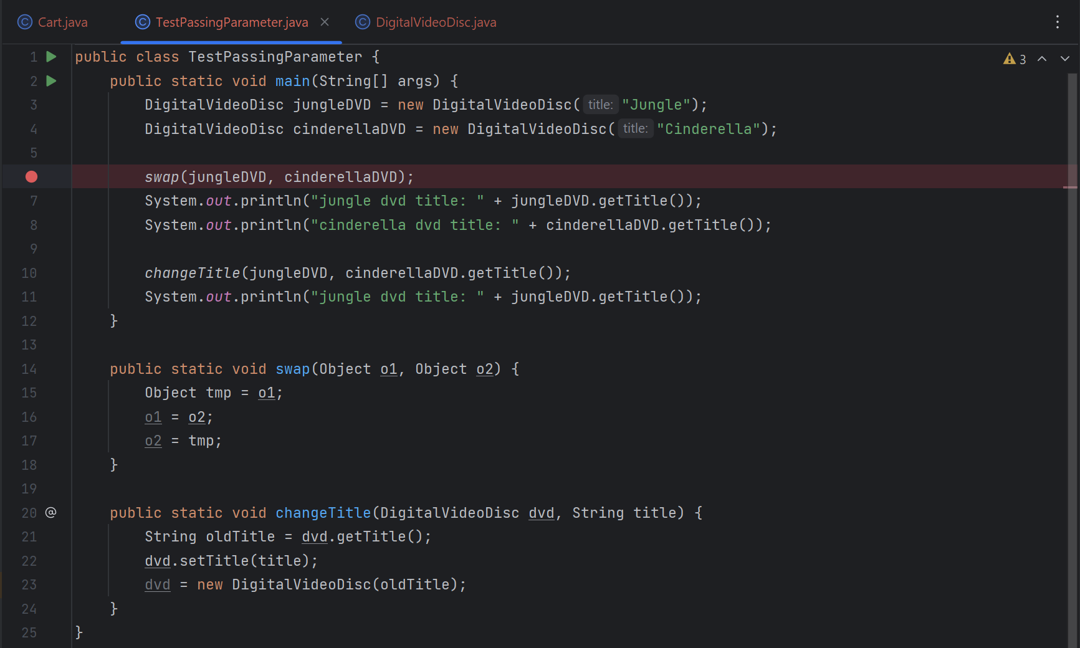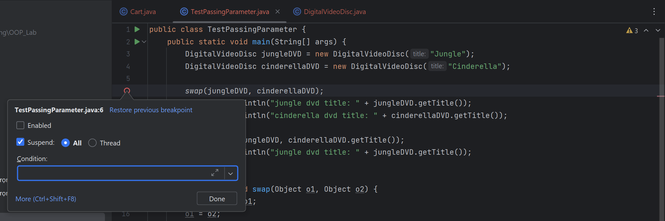

#### 4.2.2. Run in Debug mode:

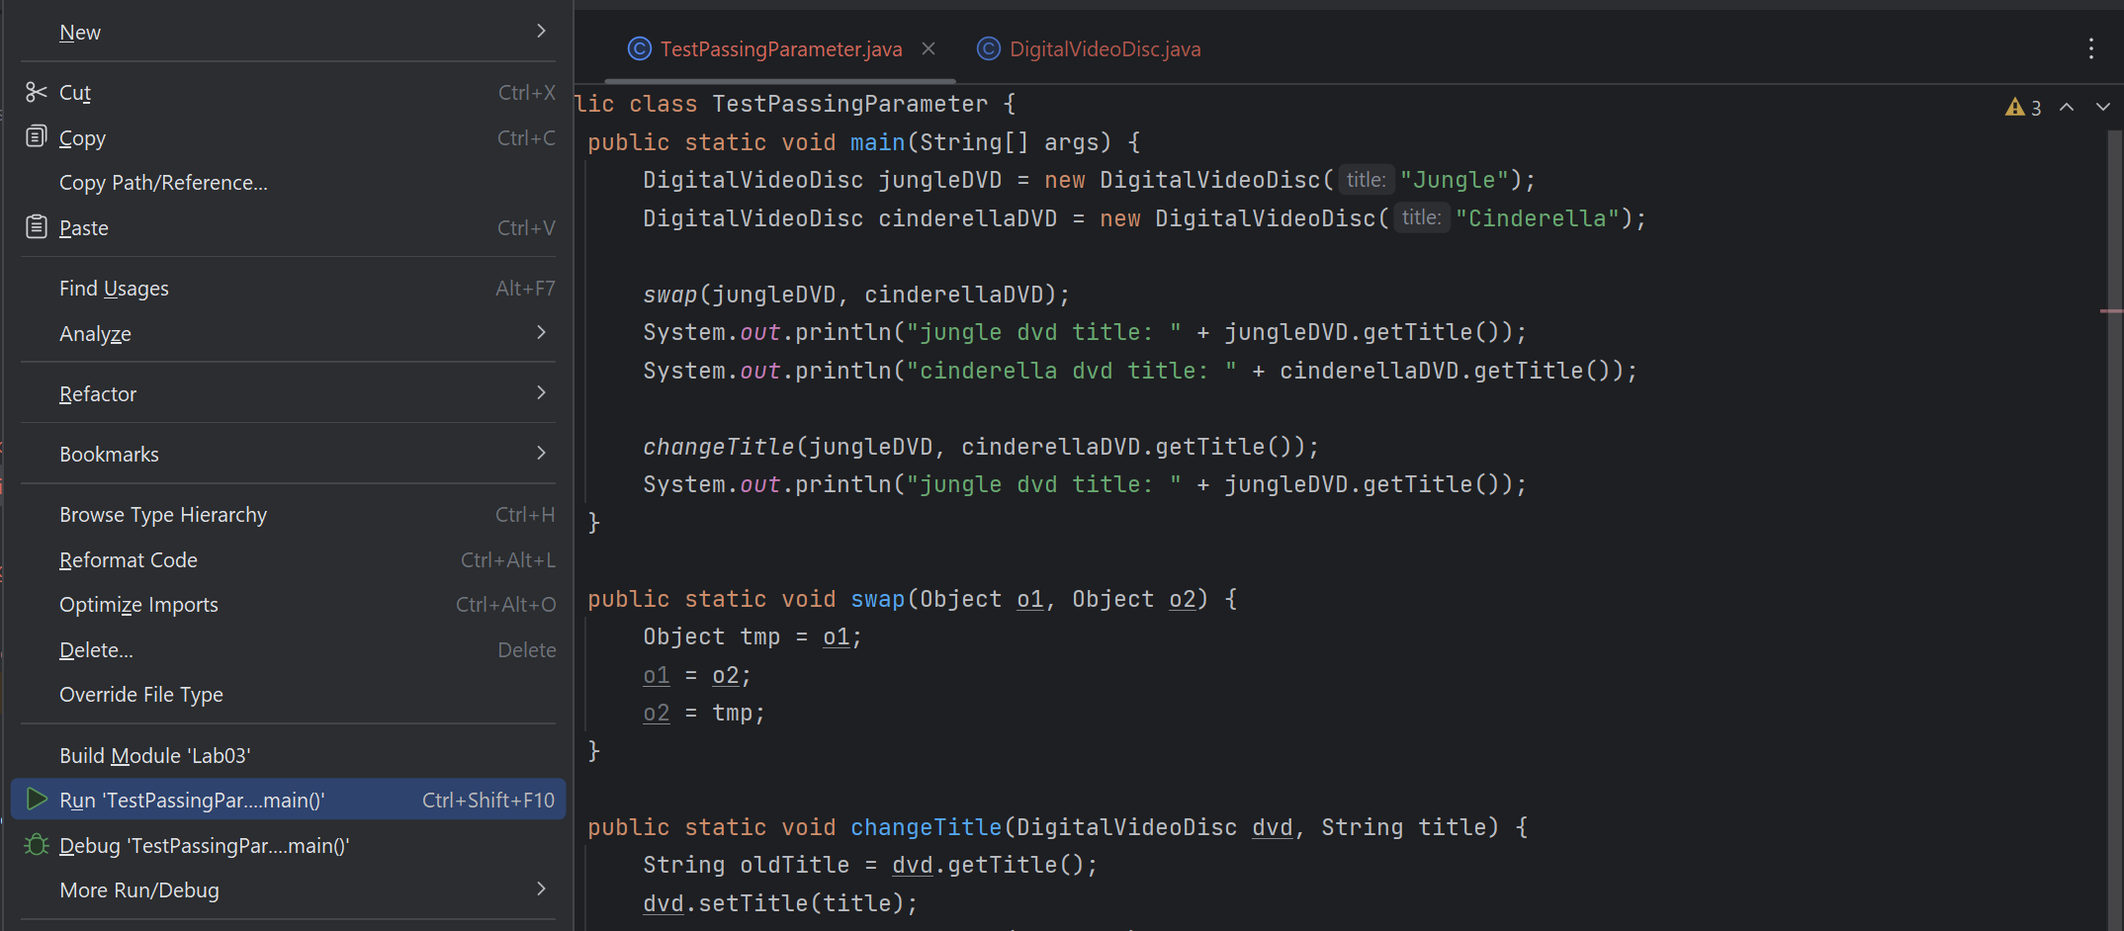

#### 4.2.3. Step Into, Step Over, Step Return, Resume:

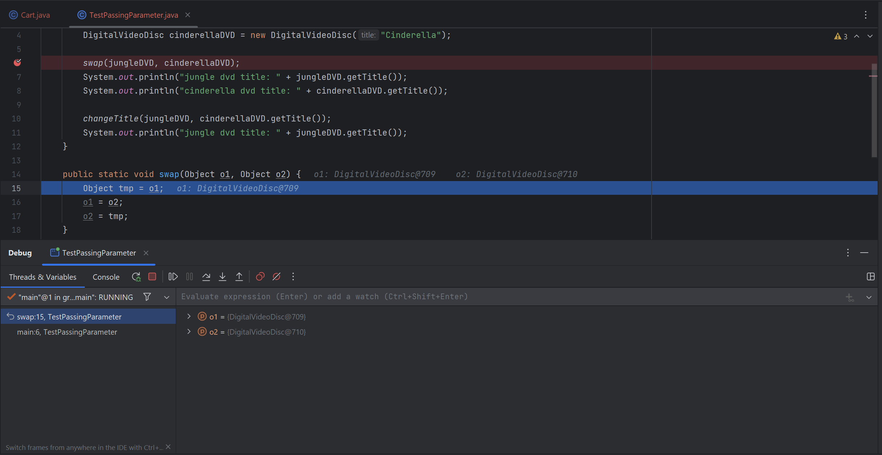

#### 4.2.4. Investigate value of variables:

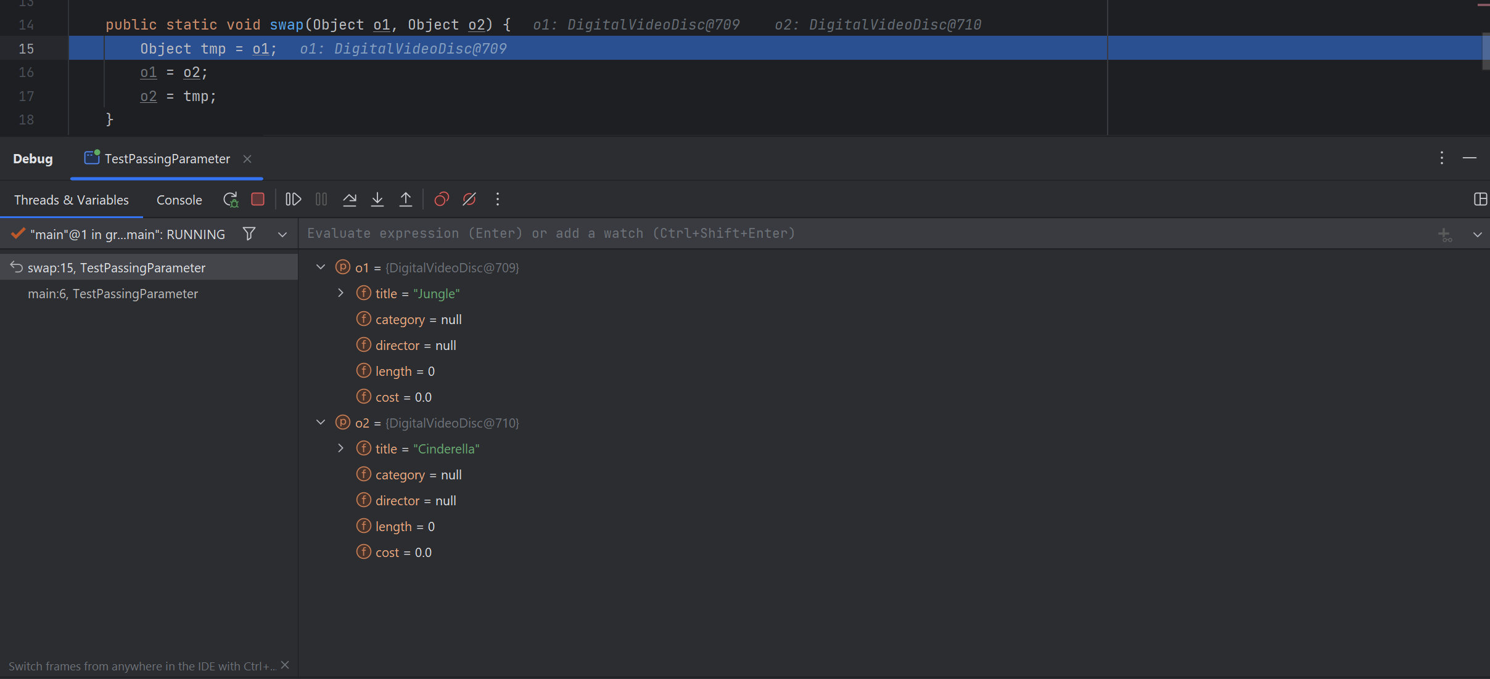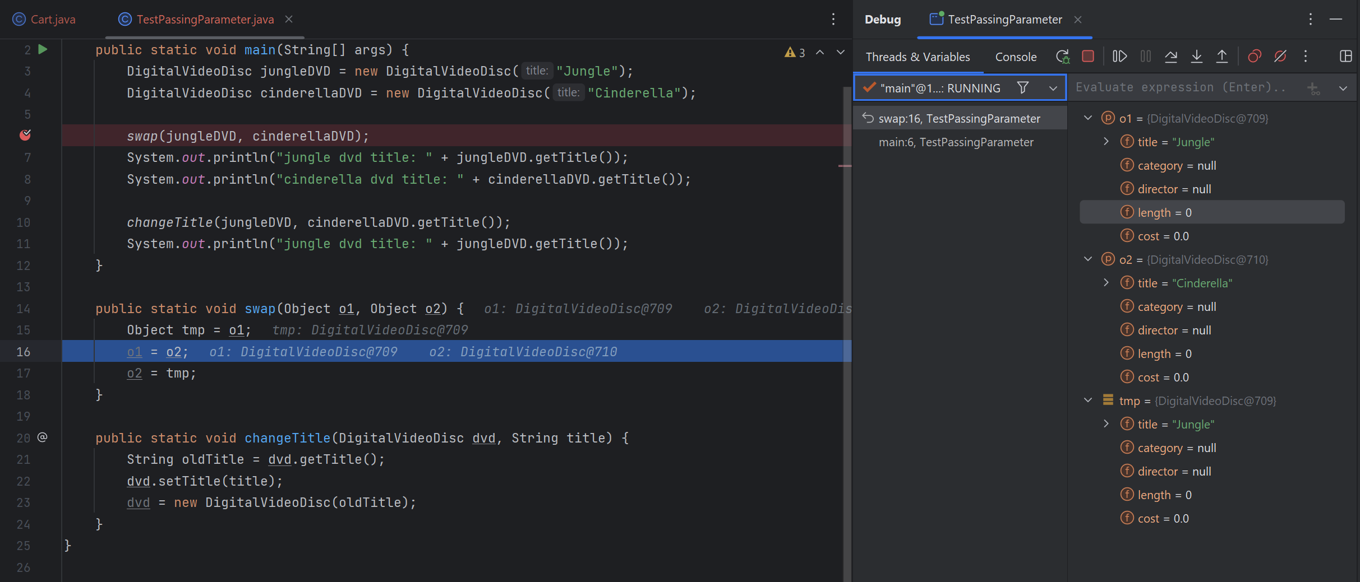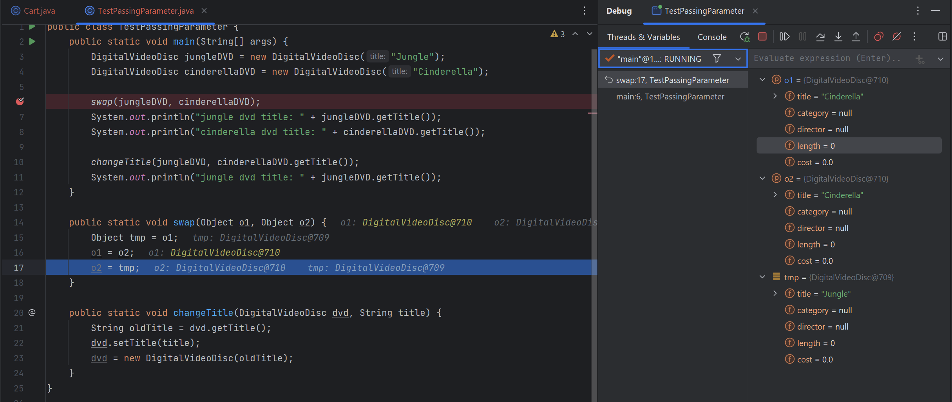

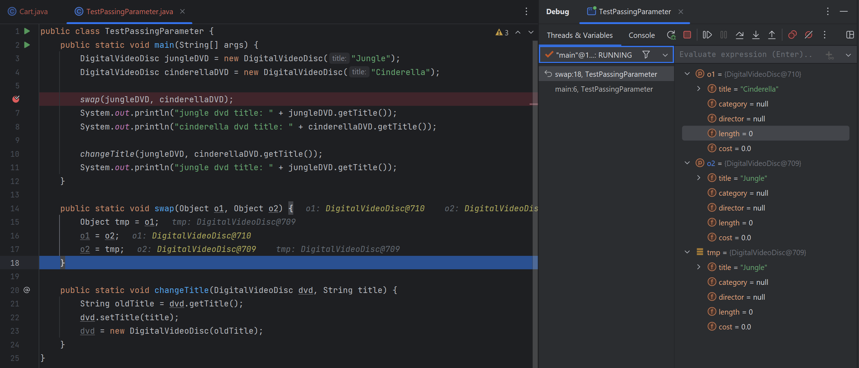

#### 4.2.4. Change value of variables:

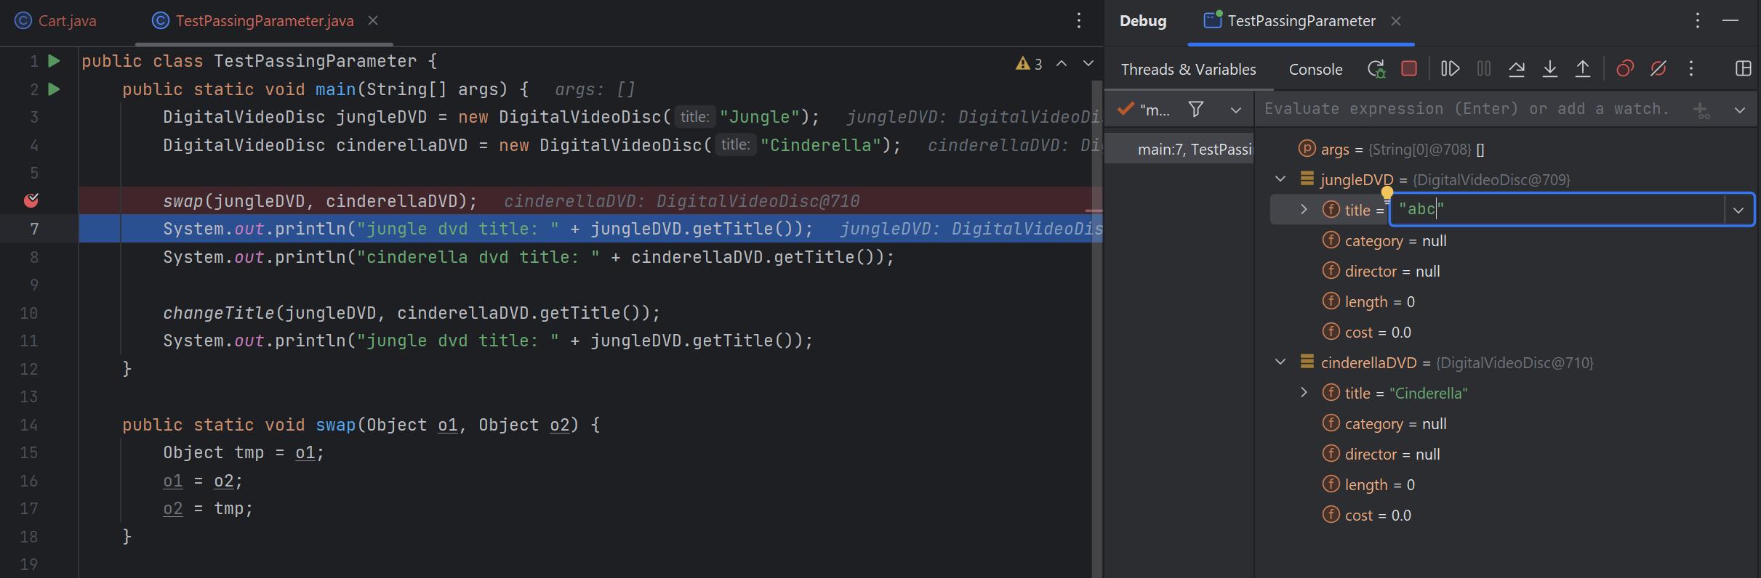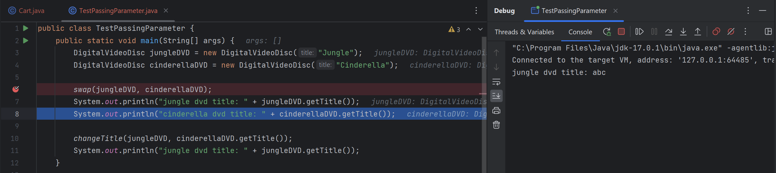

## 5. Classifier Member and Instance Member

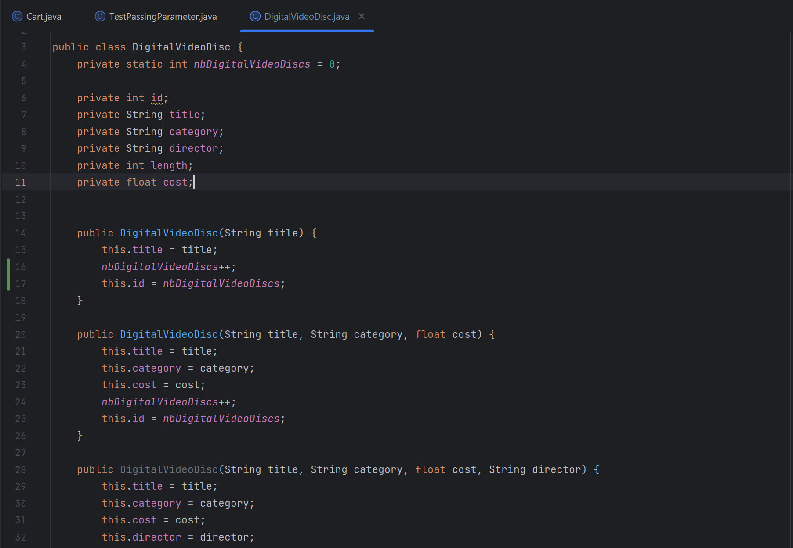

## 6. Open the Cart class

## 7. Implement the Store class

## 8. Re-organize your projects

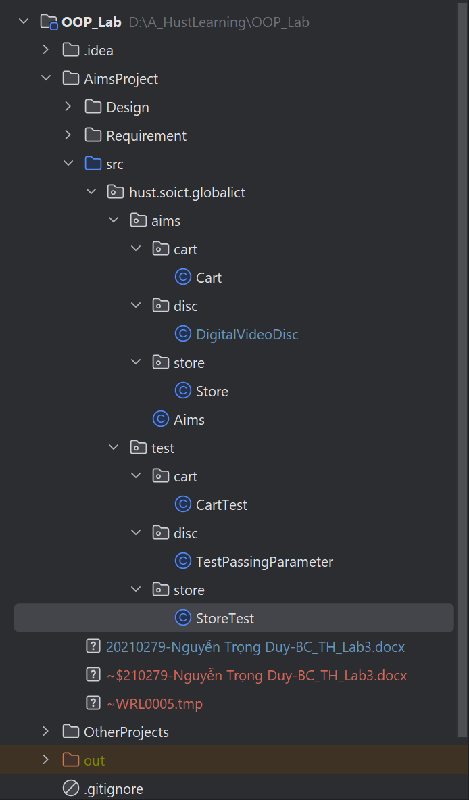

## 9. String, StringBuilder and StringBuffer

##### GarbageCreator

##### NoGarbage

